**Extrasolar Transits Focusing on HAT-P-5**

An extrasolar transit is the passage of a planet across the disk of a star which consequently reduces the light received from the star by an infinitesimal fraction. This allows us to detect whether a star has an orbiting planet, and also to study the characteristics of the planets. To do this we can use several methods including;

* Radial velocity- an isolated star will rotate around its own centre of mass, but the presence of extrasolar planets orbiting the star changes its centre of mass. This in turn causes the star to rotate slightly off centre, causing a change in velocity. This causes differences in the wavelength of light received due to the Doppler Effect, which can be measured from its line spectra, alerting scientists of the presence of extrasolar planets.
* Pulsar timing – pulsars will rotate around a centre of gravity which is usually the centre of the neutron star, unless there is a planet in orbit causing the centre of gravity to shift from the centre. This will cause the radio emission of the pulsar to have slight anomalies. Because the intrinsic rotation of a pulsar is so regular this method is sensitive enough so it can be used to detect orbiting planets as small as those a tenth of the mass of earth.
* Gravitational microlensing- when a compact object with a large mass comes between an observer and a light source, the large object triggers the light travelling from the light source to the observer to become bent, producing two images of the source. These gravitational microlensing events usually construct images of a characteristic shape. However, if the star acting as the lens has a planet orbiting round it, there will be a difference in gravitational field, causing extension and complication in shape, alerting sciences of the fact that there are two bodies acting as lenses (this method is particularly useful as it allows us to see dark or faint items, as no light emitted from the actual planet needs to be detected). Likewise, if the star acting as the source has a planet orbiting it, any crossings (lining up) of the source and lens will occur at different times, and the planet will be amplified a different amount due to the different size, so scientists will be able to see that there is another body, and also that it is a different size to the star.
* Transit method – This is where there is a change in visual brightness from a star due to a planet crossing in front of the parent star’s disk. We use photometry to determine if a star has a fluctuating brightness, however this method has a high rate of false detections so requires additional confirmation using the radial velocity method.

In our research we used photometry – When using LTimage a planet can be identified to be orbiting a star by the variance in photon count when a set of images are compared. A number of observations are taken over a period of time, and the amount of photons from each point in the sky detected, are recorded for each observation. The number of photons (the brightness/flux of the star) for each observation is compared, and any changes in brightness are observed in more detail. If a light curve is formed in which the light drops, there may be a planet orbiting the star (NB for this method, a calibration star is measured, to account for any differences due to other factors-e.g. a change in weather or difference in the angle of the telescope meaning that the light has to travel through more air).

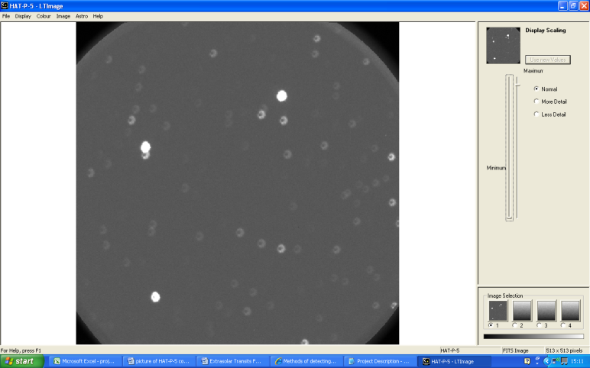We were given 100 images of HAT-P-5 from the Liverpool Telescope taken over a time period of 4 hours, 27 minutes by the RISE instrument, a fast readout camera developed for the precision measurement for transiting exoplanet timing. First we needed to identify which of the stars in the image was HAT-P-5. The focus of the images was decreased so that the photon count of the image was increased as the pixels wouldn’t become saturated due to particularly bright stars. This suggested that HAT-p-5 was one of the three brightest stars observed in the image. We then proceeded to use SIMBAD to find an image of HAT-P-5:

Defocused image of HAT-P-5 from the LT

Image from SIMBAD showing HAT-P-5 as the centre star.

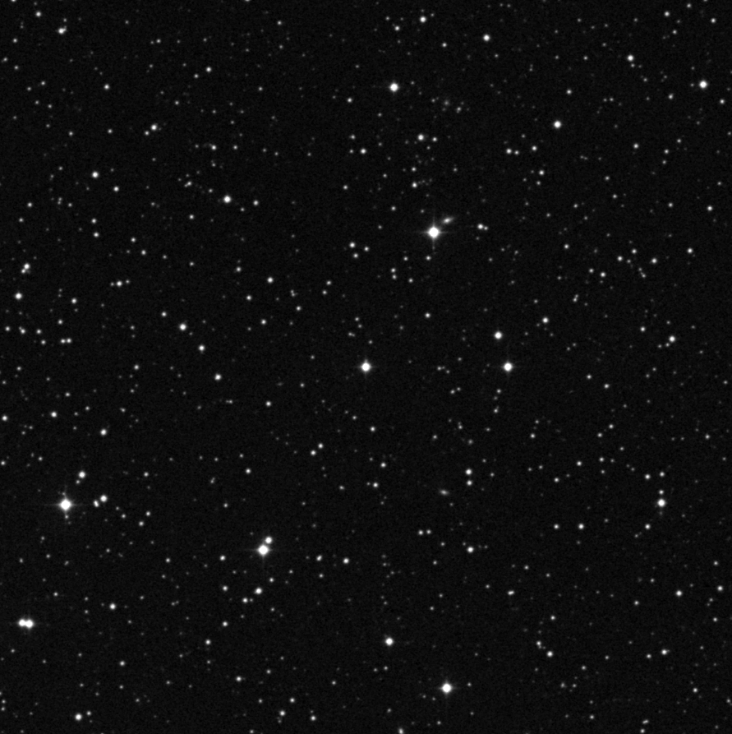 We determined which star was HAT-P-5 on the LT image by comparing the positions of the neighbouring stars in both pictures.

Once we had found HAT-P-5, we took each observation, and measured the brightness of three stars from each (HAT-P-5 and two calibration stars). We needed to take the calibration stars to account for other factors that could affect the brightness of the stars between the measurements. For example, as the night went on, the earth rotated, and the telescope turned to face the star. This meant that the light coming from the star had to come in to the earth at a greater angle, and so had to travel through more of the atmosphere, so more photons were scattered. Another factor that could have affected the photon count was the weather, as, if more clouds appeared during the night, less photons would reach the telescope. We needed to account for the possible changes, so we took measurements from other stars to determine how much the other factors were actually affecting the measurements. Using a simple sum (dividing the count for HAT-P-5 by the count for the calibration stars) , we were able to estimate what the photon counts for HAT-P-5 would be if there were no other factors that affected it. We took two stars so that, in case one star was a variable star itself, the other one could be used.

We encountered some difficulty in some of the measurements, particularly in one of the guide stars. All the measurements seemed to fluctuate randomly (as shown in the graph above), so when we tried to calibrate the HAT-P-5 star against this star, it did not come out right. These variations in the guide star that was supposedly not meant to be a variable star may have been due to incorrect reduction of the data (notably, we had to position a circle around each star to determine the area that we wanted to count the photons from for each picture, but, as this star had another star very close to it, if we placed the circle in the wrong place, we would see a very large difference in the apparent brightness)

However, as we measured data from another star, we were able to calibrate HAT-P-5 with this star, to obtain more reliable results. The graph below clearly shows that the apparent brightness dropped significantly (compared to the usual fluctuations in the brightness), and then increased again, implying that there was almost definitely a transit during this period.

The fact that the photon count decreased is evidence that light from the star was definitely blocked by the planet during the period that the observations were taken. Also, the fact that there was a **gradual** decrease in the number of photons with time (the fact that the gradient is shallow instead of a 90o) shows that there was more light in the middle of the star, which is due to the limb darkening of the star (the fact that the star becomes less bright as you go away from it’s centre). One final observation that we noticed was that the number of photons detected did not go back to the original value. We don’t know why this was, but we assume that it may be due to either a mistake in the calibration or a mistake in the original values.

Also, the fluctuations in the values may be due to wrong placement of the circle or wrong calibration.